The American Embassy Nairobi to Install Kenya’s First Ultra-Slim Unilumin P2.9 28SQM Curved Outdoor LED, Supplied by Perlogy

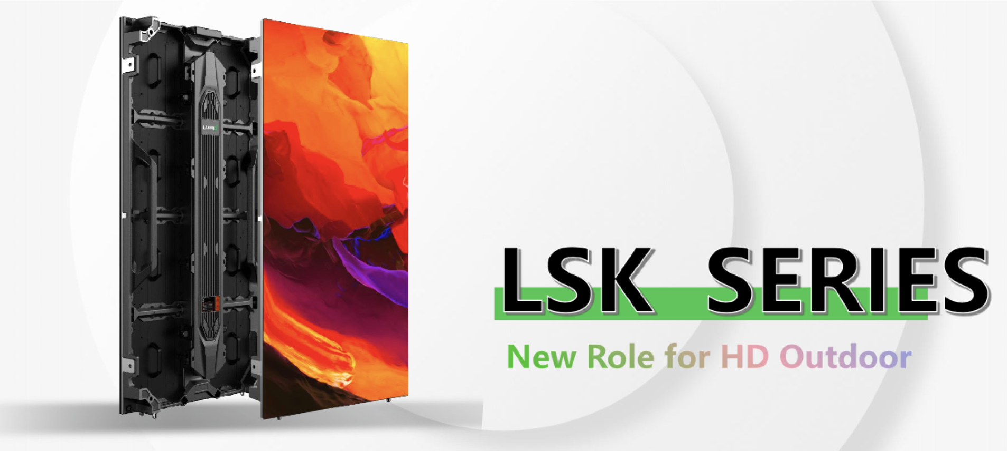

Perlogy Technologies LLC is pround to have contributed to the design and supply of Kenya’s first Unilumin P2.9 curved outdoor LED display. Awarded to local Kenyan system integrator, manufactured by Unilumin, designed and supplied by Perlogy. The project is scheduled for installation in Q1 at the American Embassy in Nairobi.
The model is from the Unilumin LSK series outdoor LED. This specific model will the Unilumin thinnest LSK P2.6 model. The LSK model comes in several variations, P2.6, P2.9, P3.9, P4.8, P5.9. both screens come in either 500mm x 1000mm or 500mm x 750mm.

Product Overview

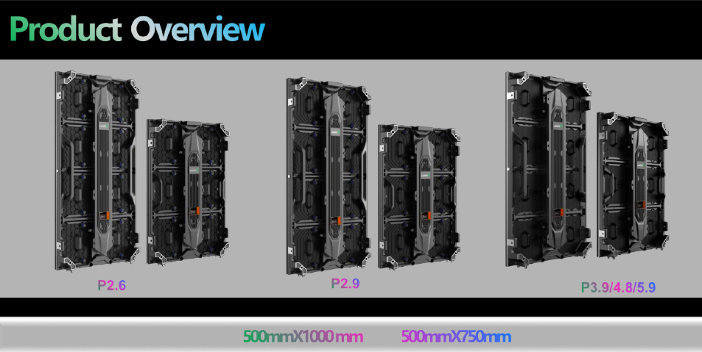

The product fits the needs of the Embassy because it is widely used in a variety of applications, its Ultra-clear, ultra-high definition and offers free customization. At the Embassy the product will be installed in an outdoor auditorium at the Embassy grounds in Nairobi.
With the Ultra-thin and light design, easy to install and integrate with the surrounding environment, the SI will experience reduced labor and transport costs during the installation process.

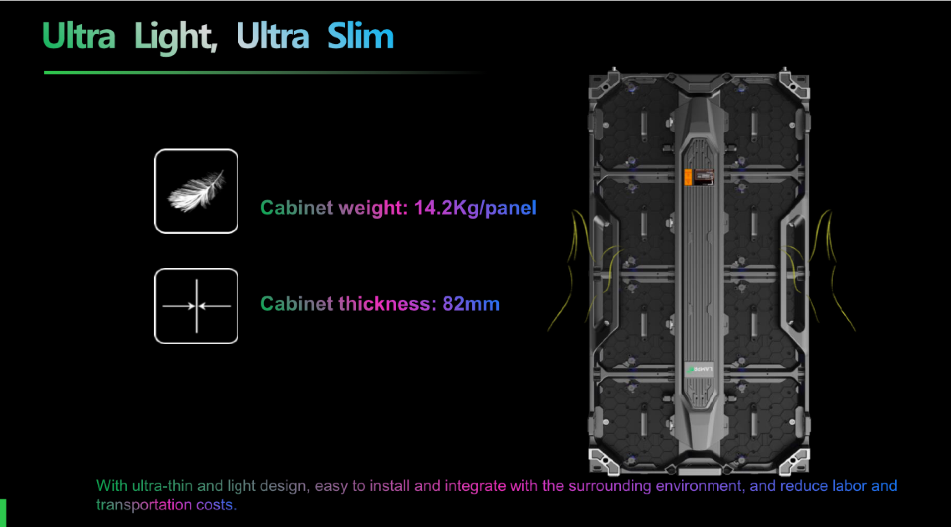

Water Proof
The product has an excellent waterproof performance at IP69K. The IP69K rating provides protection against ingress of dust and high temperature, high pressure water – making products with this certification ideal for use in conditions where equipment musßt be carefully sanitized.
In industries such as food processing, where hygiene and cleanliness is paramount, equipment must be able to withstand rigorous high pressure, high temperature wash-down procedures.
In many industries, where dust and dirt can be an issue, it is important to ensure that dust cannot penetrate the casing of a product and cause it to fail.
The IP69K rating is the highest protection available.
The IP69K rating offers complete assurance that the piece of equipment that has undergone that tests is both durable and resistant and conforms to the highest protection rating on the scale.
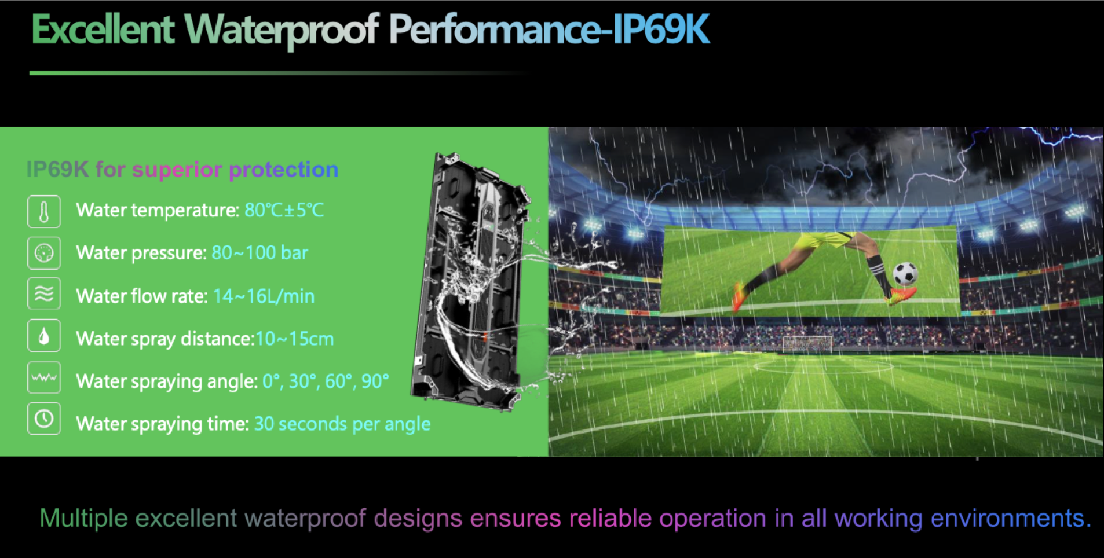

Other Features
The product has many other features such as;
- Innovative cooling design; hollow structure cabinet with large air convection are for quick heat dissipation.
- Reliable Cabinet design
- Smart module with status detection, voltage detection, temperature detection, cable detection and spot detection.
- Hassle-free anti-drop design; the industry’s 1st anti-drop structure design, worry-free with double protection design.
- Front and Rear maintenance
- Multiple installation methods; wall mount, hanging installation or embedded installation.

Contact us for an extended product description of quote if you have any LED requirement.

About Perlogy Technologies LLC
Perlogy Technologies LLC is a ProAV distributor based in Dubai focused on the African market. The company specializes in Professional Audio Visual (ProAV) and the accompanied ICT integration and distribution.
Our mission is to provide the best in quality product and priced solutions that are tailored to bridge the gap between ProAV and IT. With a commitment to excellence, we prioritize user experience, scalability, and security, ensuring seamless integration and compliance. Our collaborative partnerships with leading technology vendors keep us at the forefront of innovation.

About Unilumin
Unilumin, is the LED application pioneer, established in 2004, providing professional LED application services, including the world’s leading LED display and lighting products and Metasight solutions.
The company was listed on the Shenzhen Stock Exchange in 2011 (XSHE:300232) and has consistently been leading in the LED display industry exports for 8 consecutive years, earning the trust and support of customers worldwide.
Unilumin has been recognized as one of the top 500 most valuable brands in Asia. Its products have taken center stage in some of the world’s most iconic settings, including Times Square in New York, the 2008 Olympic Games, the 2010 Shanghai World Expo, and the 2024 Paris Olympic Games.
Unilumin’s creative LED and ultra-high definition displays and indoor and outdoor lighting solutions are relied on by partners in 160 countries and regions to bring a range of professional display, rental, and staging applications to life.
Contact us
Email: nelson@perlogy.co.ke
Phone: +254 792 651 241

